# **Learning Journal - Unit 2**

Computer Science, University of the People

CS 2203-01 Databases 1 - AY2024-T3

Instructor, Irfan Rashid Thoker

February 15, 2024

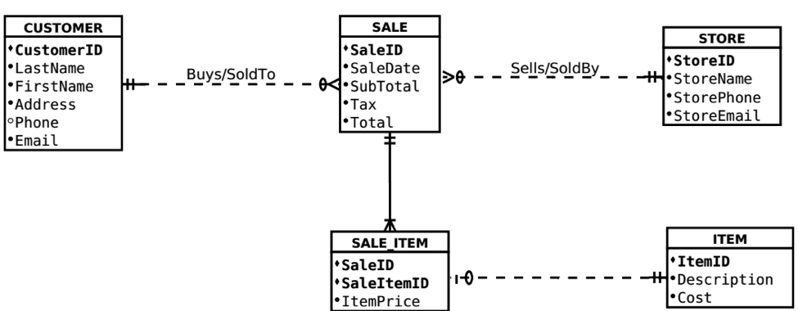For this task, I was required to do one of my favorite things and that is reverse engineering a problem. That means I know the result but I need to guesstimate the steps and stages that got us to this result.

The E-R diagram above is the result of requirements made by a client to a system designer. My job here is to try and figure out the requirements based on the entities, attributes and the relationships between them. The first thing I can understand from the Entities is that the system is most likely a retail system since it is clear that there are Customers and Sales and Items. More so I can understand that the retail store is not a single store but part of a chain of stores based on the Store entity. So I can already assume to understand that this system is a centralized database for a retail chain. I will also note that there does not seem to be any local or shared stock management in this system, meaning that all stores have an unlimited amount of all items, but since this is for educational purposes only I'm guessing that that is by choice and not an oversight.

Guesstimates & Requirements:

1. The client wants to be able to collect and maintain a list of customers that may or may not have purchased items from the retail chain.
2. The Customer details will include personal details such as full name, address, email, and phone (optional). Each user will be tracked through the system with his unique identifier (CustomerID)
3. The client also wants to manage a list of stores in the chain. Which contains the store’s details such as name, phone and email address along with a unique identifier (StoreID).
4. The client also wants a list of all items (products) that customers can purchase. Each of these will have a description and price along with a unique identifier (ItemID).
5. The client wants the customers to be able to purchase items from a store and each sale will be tracked along with the date of the sale, the subtotal, the tax paid, the items included in the sale and of course a unique identifier (SaleID)

Relationships:

1. Customer – Sale: The crow's foot with the zero tells me this is a many-to-one relationship with the option of there being no relationship at all. Meaning that each customer may have multiple sales or none at all, but each sale can only have a single customer assigned to it.
2. Sale – Store: Here also the crow's foot with the zero tells me this is a many-to-one relationship with the option of there being no relationship at all. This means that each store may have multiple sales or none at all, but each sale can only have a single store assigned to it.
3. Sale – Sale_Item: The line with the crow's foot here tells me that this is a one-to-many relationship. Meaning that each sale will have multiple sale items and always be at least one item per sale.
4. Item – Sale_Item: Here we see the line with the circle telling me that the relationship is one-to-one with the option of there being no relationship at all. This tells me that each sale item will be connected to a single item but not all items will necessarily have a sale item connected to them.

In conclusion, This diagram represents a retail chain that wants to manage its stores, customers and orders in a central database. Most likely for easier management, statistics and order processing. The orders can handle multiple items per order using a many-to-many relationship implemented using a go-between table.

## References

* Learning Guide Unit 1  
  <https://my.uopeople.edu/mod/book/view.php?id=402421>
* Learning Guide Unit 2  
  <https://my.uopeople.edu/mod/book/view.php?id=402430>
* Sharma, N., Perniu, L., Chong, R. F., Iyer, A., Nandan, C., Mitea, A. C., Nonvinkere, M. & Danubianu, M. (2010). Database fundamentals. IBM Canada.  
  <https://my.uopeople.edu/pluginfile.php/1827130/mod_book/chapter/484065/Database_Fundamentals.pdf>
* Watt, A., & Eng, N. (2014). Database design,  2nd ed. BCcampus, BC Open Textbook Project.   
  <https://opentextbc.ca/dbdesign01/>  
  <https://my.uopeople.edu/pluginfile.php/1827130/mod_book/chapter/484065/Database-Design-2nd-Edition-1560272109.pdf>